JIT5 Mix

Blend together any of the other tools into a mini e-portfolio. Add a picture to some text on one page, then move on to an animated story on the next, for example.

The mix tool is similar to PowerPoint, where you can choose to add text and images to pages from the mix ‘play’ layout.

To use the mix tool click on the black mix tab at the top of the page.

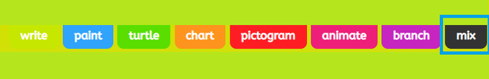

Select a mix play layout and click on the green tick.

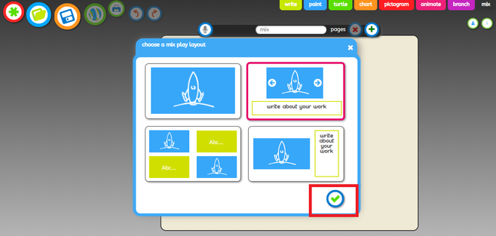

Click on the green * symbol at the top of one of the work areas on your page to add a background template or picture.

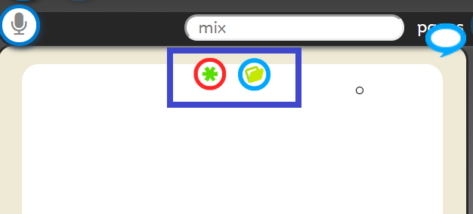

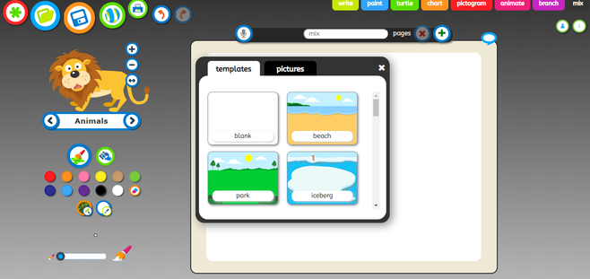

In writing areas (indicated as ‘Abc…’):

Change the font, size and colour, use the options on the left hand side of the page.

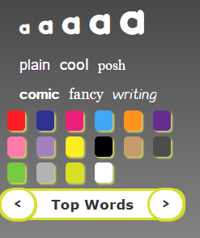
You can add a word from a word list by clicking the arrows underneath the colour options. Scroll through the topics and then click on a word of your choice. This can also be used to add Welsh character accents.

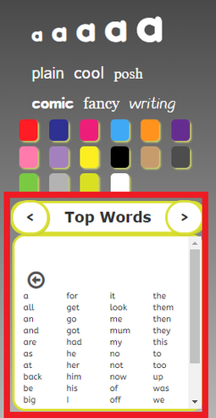

In paint areas (blank spaces):

Use the controls on the left hand side of the page to change the thickness of your paint brush and a colour. You can switch to the fill option by clicking on the spilling paint can icon, which will enable you to fill a space with one colour.

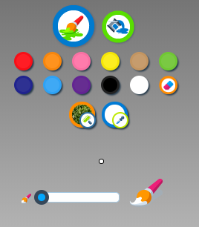

To add animations to your work, click on the word that appears between two arrows on the left hand side of the page. Select a theme from the dropdown list and then use the arrows to find an animation you would like to add. Use the + , - and arrow buttons to resize and flip your animation. You can then drag and drop it onto your background.

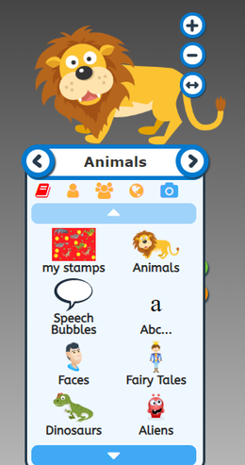

To add a voice recording to the slide, click on the microphone button at the top of the page.

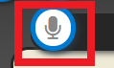

To add a new slide, click on the green + at the top of the page. You will then be asked to select another mix play layout for the new slide.

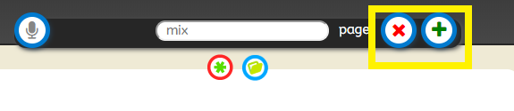

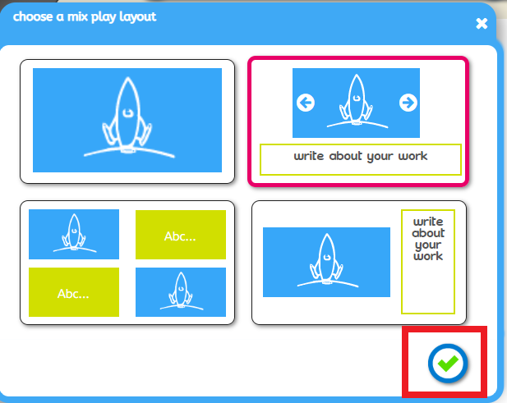

Use the arrows on either side of the page to scroll between slides.

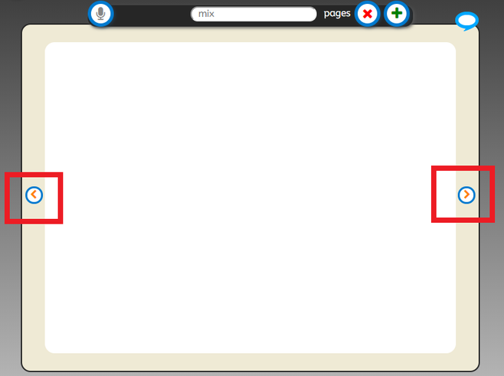

How to save

Rename your work and then press the save icon.



