JIT5 Branch

Branch brings sorting and sequencing to life by making it very simple to create branching databases. Select a group of images or words and use yes/no questions to sort them and create a branching database.

To use the branch tool click on the purple branch tab at the top of the page.

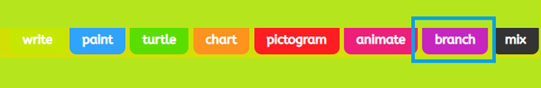

Here you can select a template or insert your own picture. By selecting 'picture' you are given the choice of adding an uploaded picture, searching google for an image or taking a photo.

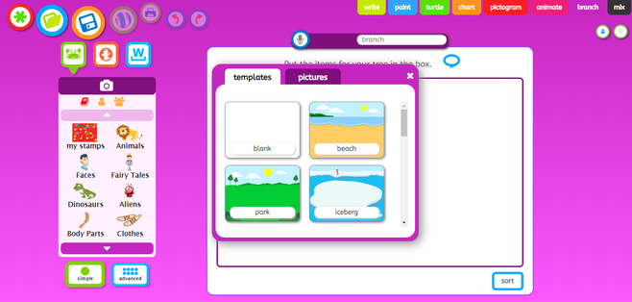

Put the items you would like in your branching tree in the box on the page using the controls on the left hand side.

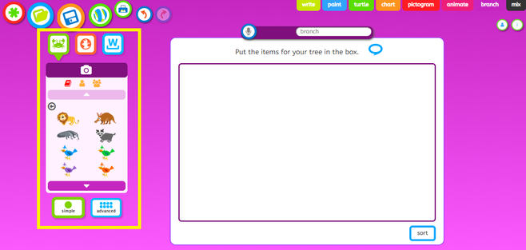

Click on the green crab button to search through animations, the orange button to search the web and the blue W button to search through word lists. Click on one of the options to add it to your page.

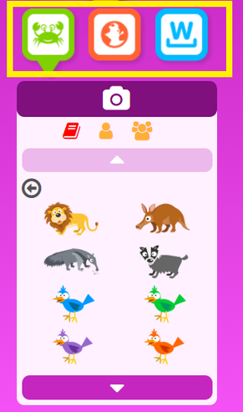

Once you are ready to sort the items, click sort (in the bottom right hand corner of the page).

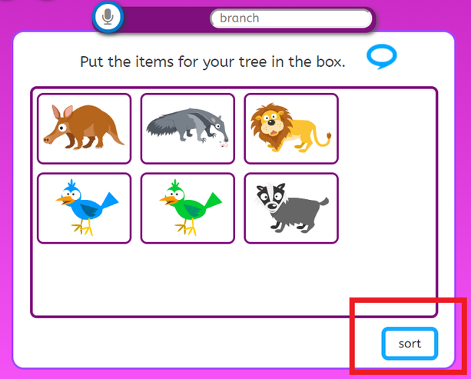

Type a question into the pink question bar and then you can begin dragging and dropping your items into the correct columns.

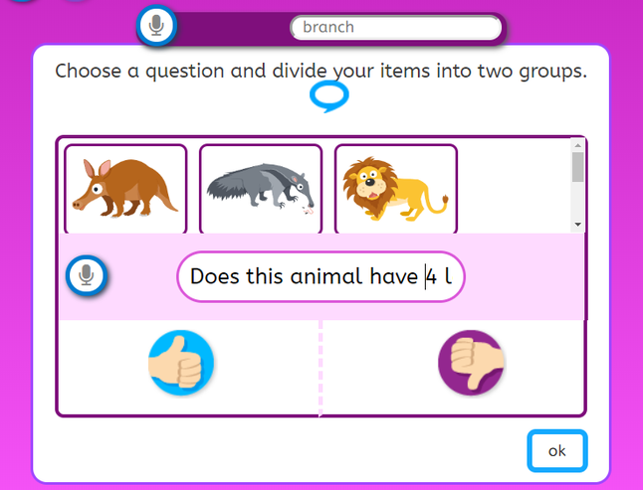

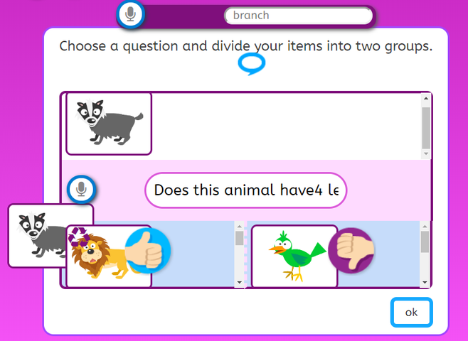

Continue to complete your branch questions until you have no characters left. Once you have finished, click ok and your branching diagram will appear.

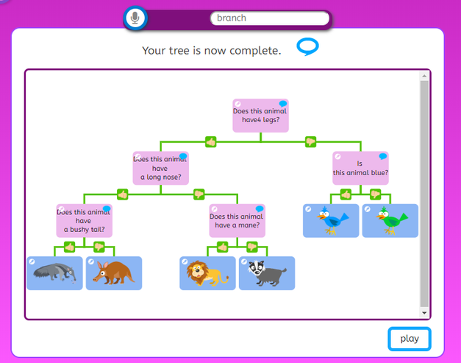

Press 'Play' to try out your Branch.

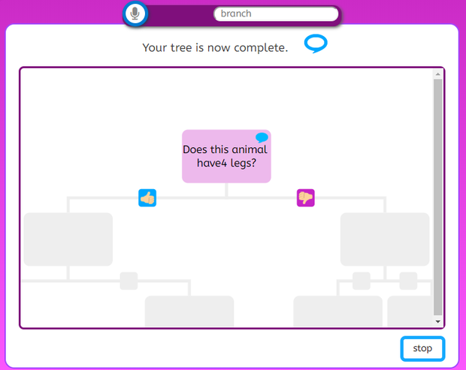

How to save on Branch

Rename your work and then press the save icon.



