Animate

Animate is a tool for creating simple but exciting animations. The best way to use animate is to draw a picture in paint, then use animate to make part of it move. Make snowflakes fall, crabs scuttle, and cars race.

To use the animate tool click on the pink animate tab at the top of the page.

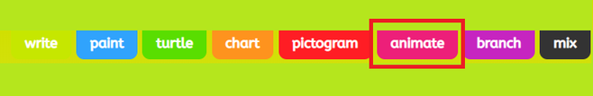

Here you can select a template or insert your own picture. By selecting 'picture' you are given the choice of adding an uploaded picture, searching google for an image or taking a photo.

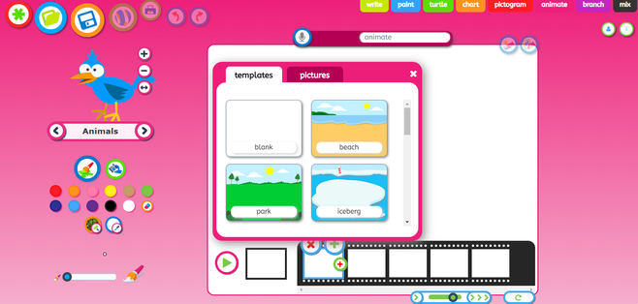

You can draw using the paint tools or select an animation picture to add to your video.

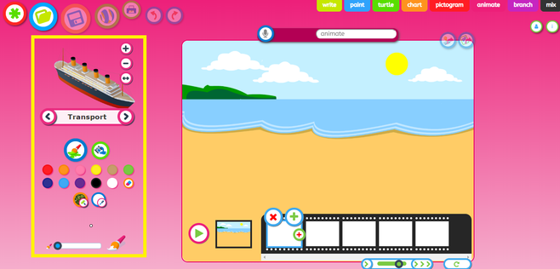

Use the controls on the left hand side of the page to change the thickness of your paint brush and a colour. You can switch to the fill option by clicking on the spilling paint can icon, which will enable you to fill a space with one colour.

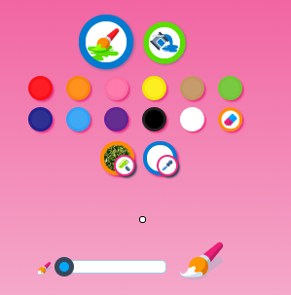

To add animations, click on the word that appears between two arrows on the left hand side of the page. Select a theme from the dropdown list and then use the arrows to find an animation you would like to add.

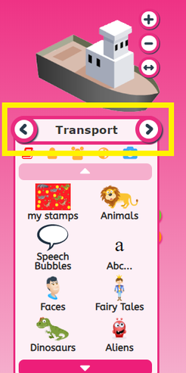

Use the + , - and arrow buttons to resize and flip your animation. You can then drag and drop it onto your background.

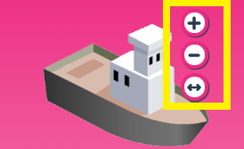

Use the green + to add additional clips to your video, the animation that you have added in your previous clip will appear greyed out so you can see where the previous slide starts.

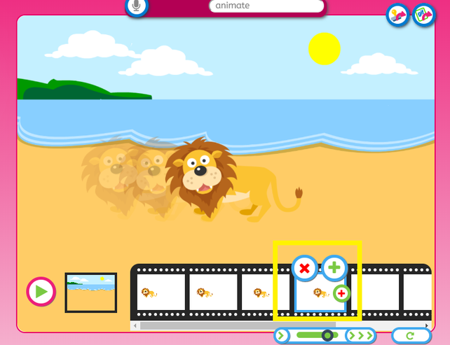

To copy a slide click on the small red + and to delete a slide from your animation click on the red X.

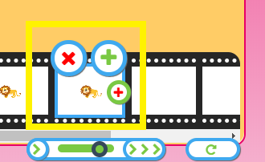

Click on the green play button at any time to play your animation.

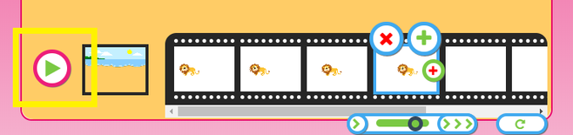

Use the arrows below to speed up or slow down your animation. You can also undo and redo actions.



How to save on Animate

Rename your work and then press the save icon.

You can also use the save as a stamp or save as a gif icons shown in the black square below


