JIT5 Pictogram

A fun introduction to data handling. Pick from a range of topics such as colours, pets or favourite fruits then click the buttons to add or take away the relevant pictures. Draw your own pictures or select from the picture bank.

To use the pictogram tool click on the red pictogram tab at the top of the page.

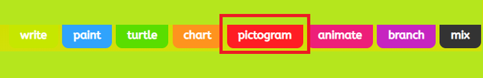

Select a template or picture as the basis of your pictogram.

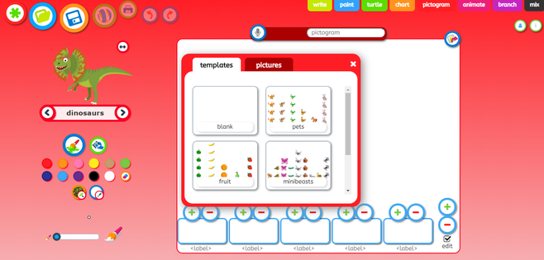

Enter your data by clicking on the + and - symbols above each picture on your page.

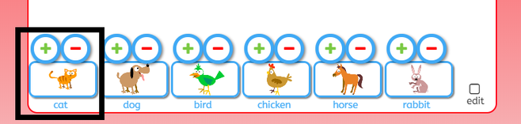

To change the pictures in your pictogram, click edit (in the bottom right hand corner of your page).

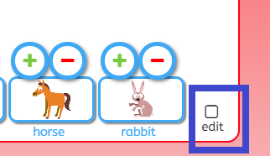

This will bring up options on the left hand side of the page.

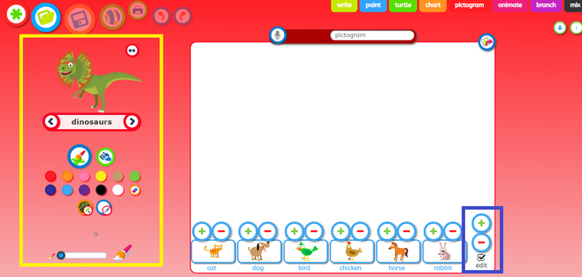

Click on the word that appears between two arrows and select a theme from the dropdown list. Use the arrows to find a picture you would like to add and then drag and drop it onto your pictogram

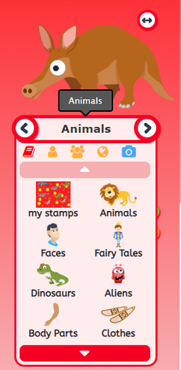

Use the controls on the left hand side of the page to change the thickness of your paint brush and colour. You can also switch to the fill option by clicking on the spilling paint can icon, which will enable you to fill a space with one colour

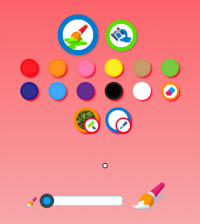
How to save

Rename your work and then press the save icon. You can also use the save as a stamp or image icons show in the black square below.



