JIT5 Chart

Chart gives the simplest introduction to line, block, pie, and bar charts. Simply mix one or more chart type together on the page. You will see the charts update instantly as the numbers in the table are changed.

To use the chart tool click on the orange chart tab at the top of the page.

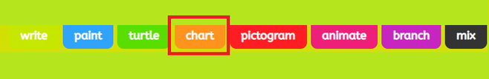

Here you can select a template or insert your own picture. By selecting 'picture' you are given the choice of adding an uploaded picture, searching google for an image or taking a photo.

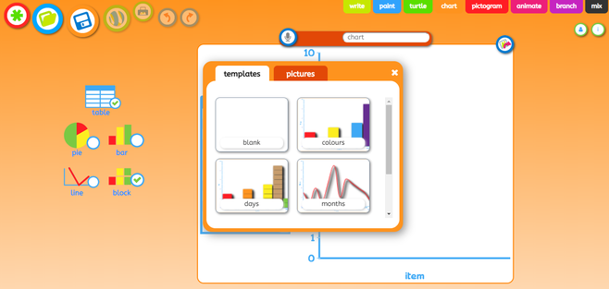

Populate the table on your page with the data you would like to appear in your chart by highlighting the existing data and typing over it. Your chart will update as you are doing this.

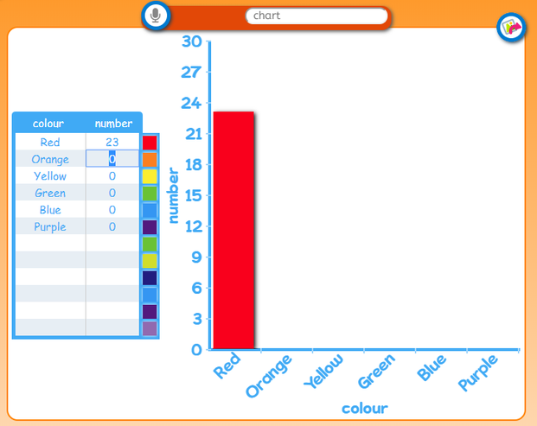

You can change the name of your chart by clicking on the title above your chart and typing a new name.

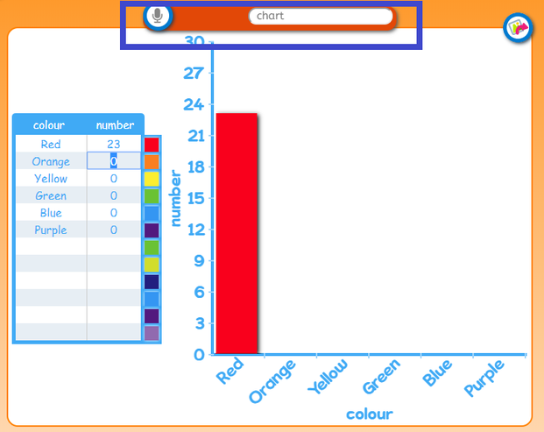

To change the style of your chart (there are four options: pie, bar, line and block), select one of the options on the left hand side of the page. You can hide your table by deselecting it.

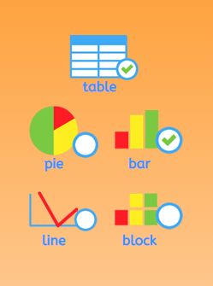

How to save on Chart

Make sure to name your work and then press the save icon.

You can also use the save as an image by selecting the icon shown in the yellow square below.



