JIT5 Turtle

Turtle teaches the initial concepts of direction and simple programming. You can design your own ‘turtle’ and plan a route for it to follow. Have a look at the fantastic nursery rhyme and adventure templates that are included.

To use the turtle tool click on the green turtle tab at the top of the page.

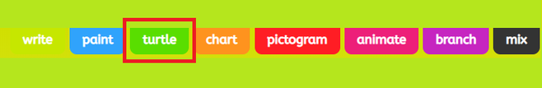

Here you can select a template or insert your own picture. By selecting 'picture' you are given the choice of adding an uploaded picture, searching google for an image or taking a photo.

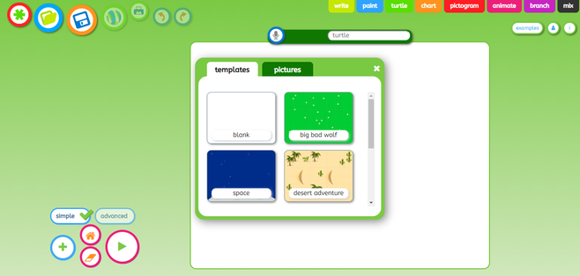

Press the plus '+' icon on the left of your screen to choose a sprite (character)

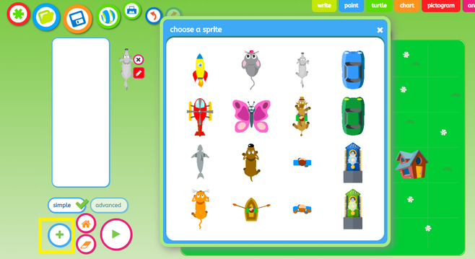

The default setting is simple however you can change this to advanced by clicking advanced on the left hand side of the page.

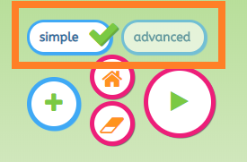

When using the simple level, the character will move as you press the arrow motion buttons around it.

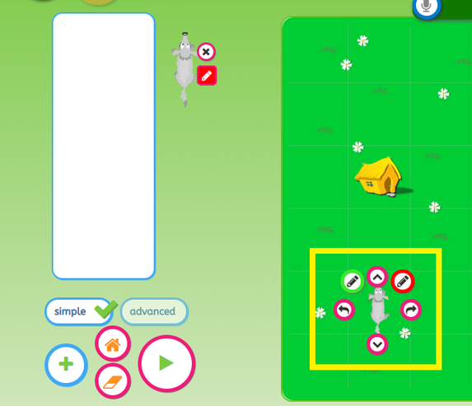

If you select the green circle with the pencil in it you are able to put a pen down and draw out your route. Press the red cirlce with the pencil to stop drawing.

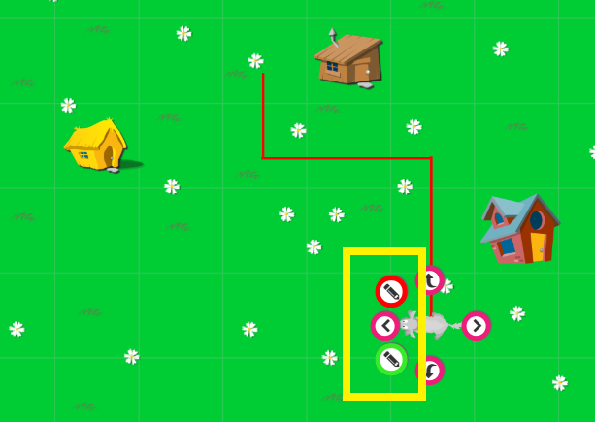

Your code with appear to the left of your screen.

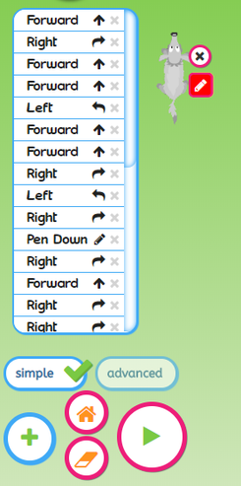

The buttons to the left of the screen will help you during your coding. Press the 'house' icon to put your sprite (character) back to its starting postion. The 'play' icon to start your code and see if it works and the 'erase' icon to delete your code.

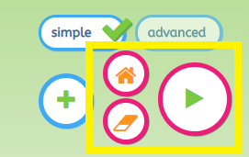

If you need to change the order of any code just click on the code you want to swap, then drag and drop it to its new position. You can also press the 'X' to remove the line of code.

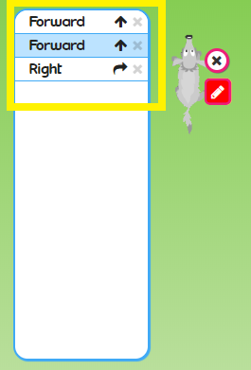

In the advanced level the character won’t move when you press the arrow motion buttons, it will only move after you have guessed the motion using the arrow motion buttons and then pressed the green play button (in the bottom left hand corner of the page).

How to save your work

To save, rename your work and press the save icon.



