JIT5 Paint

Paint is an easy to use creative tool that allows you to paint freely with different sizes and colours. You can add shapes and stamps, as well as colourful template backgrounds, and pictures from a picture bank.

To use the paint tool click on the blue paint tab at the top of the page.

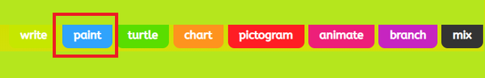

Here you can select a template or insert your own picture. By selecting 'picture' you are given the choice of adding an uploaded picture, searching google for an image or taking a photo.

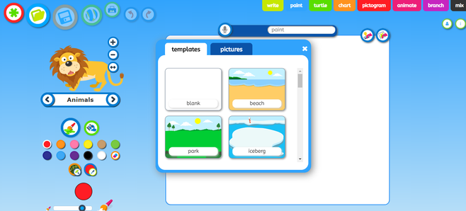

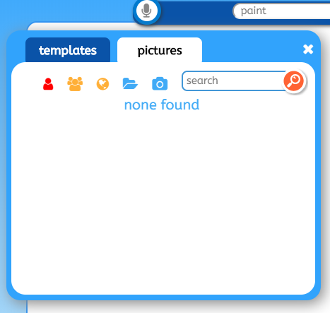

Use the controls on the left hand side of the page to change the thickness of your paint brush and colour.

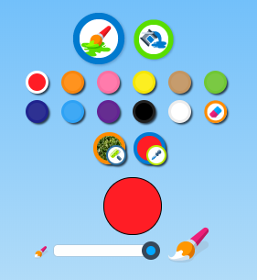

You can also switch to the fill option by clicking on the spilling paint can icon, which will enable you to fill a space with one colour.

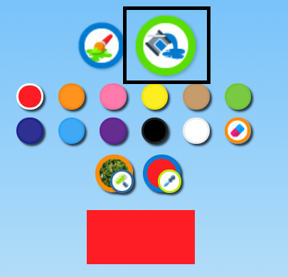

To add animations to your work, click on the word that appears between two arrows on the left hand side of the page.

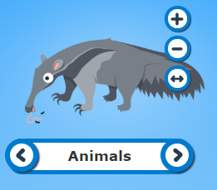

Select a theme from the dropdown list by clicking on the word 'animals' and then use the arrows to find an animation you would like to add.

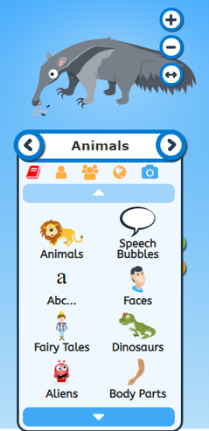

Use the + , - and arrow buttons to resize and flip your animation.
You can then drag and drop it onto your background.

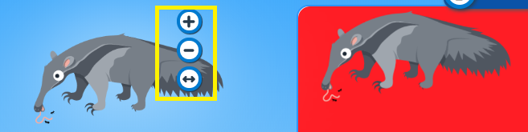

How to save on paint

Rename your work and then press the save icon. You can also use the save as a stamp or image icons show in the black square below.




