JIT5 Write

Open JIT5 and select 'Write'.

Here you can select a template or insert your own picture. By selecting 'picture' you are given the choice of adding an uploaded picture, searching google for an image or taking a photo.

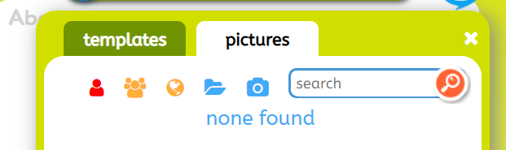

How to add text

Click on the text box to start writing. You can change the font, colour and size of the text by using the tools to the left of the page.

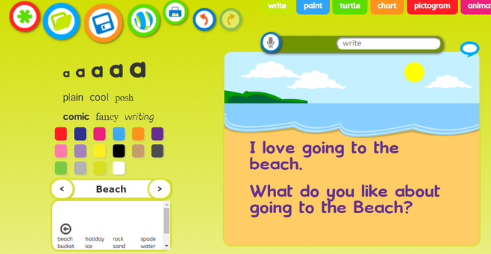
When you have added some text you can now click on the speech bubble icon and JIT5 will read out what you have written.



Click the buttons shown below if you want to undo or redo an action.



How to save

Rename your work:

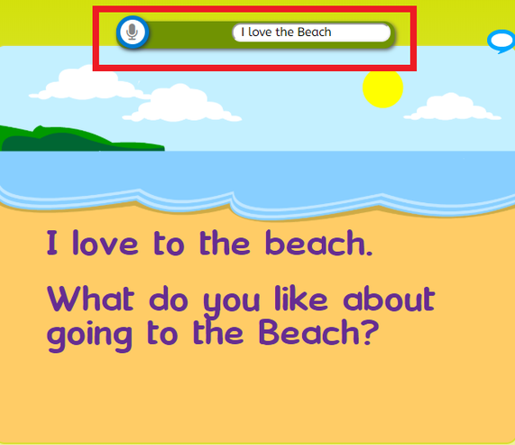

Then press the save icon:



