What is JIT5?

J2e Infant Tools (JIT5) is a set of online educational tools specifically designed for younger learners. It has a colourful and friendly feel which appeals to reception and KS1, whilst tools such as chart are useful well into KS2.

JIT5 includes the following tools:

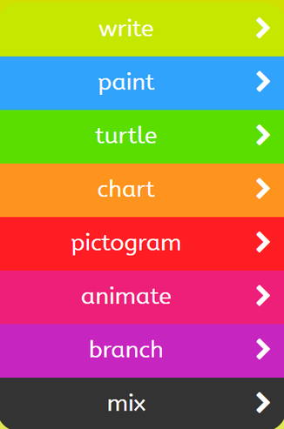

How to load JIT5

When you have signed into HWB, select 'Just2easy'. On the Just2easy homepage you can then select 'JIT5'.

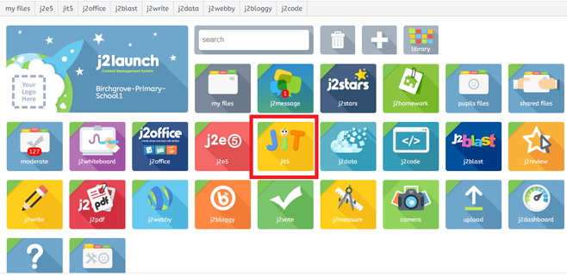

JIT5 will then open and will look something like this:

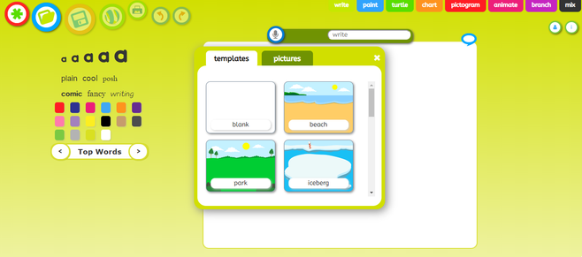

Helpful tools in JIT5

The tools shown below will allow you to create a new JIT5 document, load a JIT5 file, save your document, publish and print your work.



