How to create a collage on Spark Post

When you have logged in with HWB and selected ‘Adobe Spark’ you will be directed to the Adobe Spark homepage. We are going to look at creating a collage on Adobe Post.

How to design your own collage

Use the toolbar to the right of your screen to change the design of your collage.

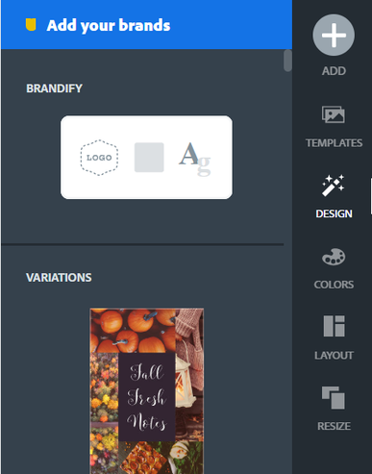

By clicking the plus '+' button you can then add text, icons, images and logos to your collage.

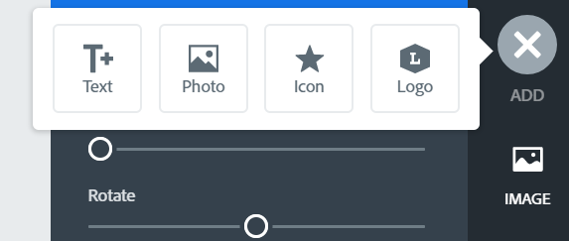

Select 'text' to add some writing to your collage. You can then choose a design and change the colours.

Double click on the writing to add your own text.

You could add dates, different languages, icons, whatever you like to make your collage super exciting.

How to download and save

Just like before you either press 'download' to save an image (png) to your device or you can press share to get a link to email or send to whoever you like.

Remember to rename your work to save it.



