What do we mean by kindness?

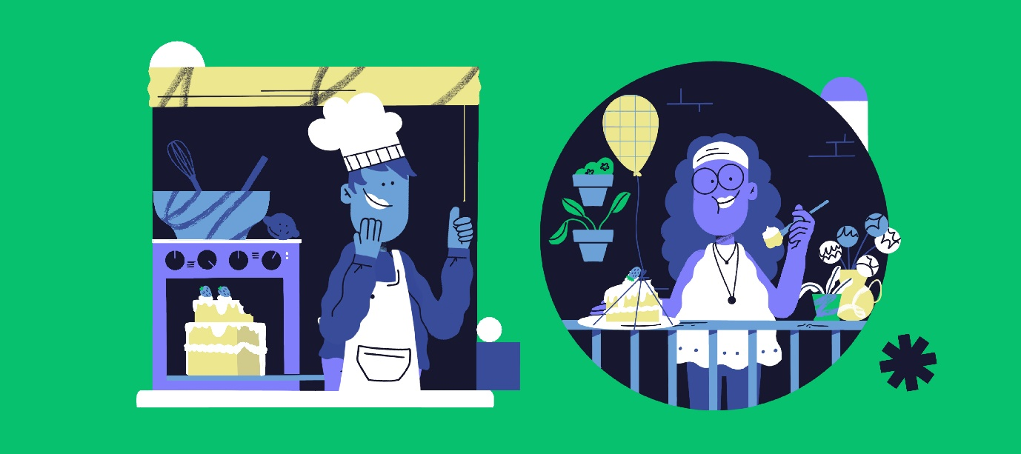
Kindness is choosing to do something that helps others or yourself, motivated by genuine warm feelings.
Kindness, or doing good, often means putting other people’s needs before our own. It could be by giving up our seat on a bus to someone who might need it more, or offering to make a cup of tea for someone at work.
Evidence shows that helping others can also benefit our own mental health and wellbeing. For example, it can reduce stress as well as improve mood, self-esteem and happiness.^{1–3}
There are so many ways to help others as part of our everyday lives. Good deeds needn’t take much or cost any money.
Small changes can make a big difference.
This guide gives you tips on how to bring kindness into your life. We will look in more detail at:
- Volunteering
- Doing something for a good cause
- Acts of kindness


What are the health benefits of kindness?

Helping others feels good
Studies have found that acts of kindness are linked to increased feelings of wellbeing. Helping others can also improve our support networks and encourage us to be more active. This, in turn, can improve our self-esteem. There is some evidence to suggest that when we help others, it can promote changes in the brain that are linked with happiness.

It creates a sense of belonging and reduces isolation
Helping others is thought to be one of the ways that people create, maintain, and strengthen their social connections.
For example, volunteering and helping others can help us feel a sense of belonging, make new friends, and connect with our communities.
Face-to-face activities such as volunteering at a food bank can also help reduce loneliness and isolation.

It helps keep things in perspective
Many people don’t realise the impact a different perspective can have on their outlook on life.
There is some evidence that being aware of our own acts of kindness, as well as the things we are grateful for, can increase feelings of happiness, optimism and satisfaction.
Doing good may help you to have a more positive outlook about your own circumstances.

It helps to make the world a happier place – one act of kindness can often lead to more!
Acts of kindness have the potential to make the world a happier place. An act of kindness can boost feelings of confidence, being in control, happiness and optimism.
They may also encourage others to repeat the good deeds they’ve experienced themselves – contributing to a more positive community.

The more you do for others, the more you do for yourself
The benefits of helping others can last long after the act itself, for those offering kindness, and those who benefit. This, in turn, can improve our self-esteem.

Tips to remember before you start

Do something you enjoy
At times like this we are learning to adapt to the requirements needed to prevent the spread of coronavirus. As a result we have had to rethink the way we do our hobbies, and pursue our interests.
You might have treated a friend to a trip to the cinema or for dinner, but today, you can watch something on a streaming service and keep in touch by phone or gift them a takeaway instead. You could even gift a subscription to an entertainment service, magazine or drop off (safely) a simple care package.
You can share your skills, such as offering to help with technology, sharing recipes, or sewing masks or scrubs for key workers. These are all great ways to bring your skills and interests to others.

Keep others in mind
Although acts of kindness for other people can make us feel good, we need to also keep in mind why we’re doing it – which is for their benefit, not ours.
Part of being kind is considering the feelings of others, so it is very important that your kindness is something which others will find helpful. Kindness is something that needs to benefit both parties.
See what you can do that others are not doing already. For example, if you want to donate to a foodbank, see what they need before buying things. If you want to support key workers, check that there is a need where you are. It may be that others in your community need help more urgently.

Don’t overdo it
It’s important to make sure we don’t overdo it!
If we find we are giving too much of ourselves or have gone beyond our means, it’s probably time to take a step back. It’s very easy to give away all of our energy, especially if we are finding things hard ourselves and want to focus on others. Leave enough for you – kindness has to start with yourself.
We recommend starting small, so we do not become overwhelmed or give more than we are financially able.
Helping others doesn’t have to cost money or take a lot of time. It could start with calling a friend we haven’t spoken to in a while or donating a small amount of money monthly to a charity close to our heart and within our budget.

Get involved with volunteering
Volunteering is a great way to help others and research shows that it benefits people of all ages, through increasing feelings of self-esteem, social connection, and wellbeing.
If you have friends or neighbours who are shielding (because of coronavirus) and can’t leave the house, see what you can do to help.
If you have time, especially if you are furloughed from work, you could volunteer in your community if it’s safe for you to do so.

Here are some ideas about getting involved:
- Volunteer for a local community organisation
- Offer your expertise and support as a mentor for those who are struggling
- Check in safely with a neighbour who is isolated or shielding
- See if there’s anything you can do to support your children’s school or nursery – offer to read stories by video for example
- Involve your friends and neighbours in community projects
- You could start up an online book club or film club
- Offer to skill-share with a friend via video call - you could teach guitar, dance or a new recipe.
- Call a friend that you haven’t spoken to for a while
- Tell a family member how much you love and appreciate them
To find out more about volunteering opportunities, check out our suggested organisations at the end of this guide.

Doing something for a good cause
Getting involved with a cause that is close to your heart can be hugely beneficial for both the cause and your own sense of wellbeing.
For example, if you want to help protect the environment, you could get involved in a local tree-planting scheme.
It may be on hold during the coronavirus lockdown, but you could start by identifying a few local organisations to contact about how they can use volunteers.

There are lots of other ways you can get involved:
- Follow your chosen charity on Facebook, Twitter or Instagram and join in with the conversation
- Sign-up to receive your charity’s newsletter and keep up to date with the work they’re doing. You can sign up to the Mental Health Foundation’s newsletter here: mentalhealth.org.uk/newsletter
- Plan a fundraising event in your local community or at work once it’s safe – why not try our Tea & Talk event, or a virtual challenge during coronavirus restrictions?
- Raise money by taking part in a fun active challenge, such as a 5k run or walk in fancy dress, or maybe a themed sports day. Again, this might need to be online for a while, due to coronavirus.
Whatever you decide to do, make sure you have fun with it!

Acts of kindness
Acts of kindness have the potential to make the world a happier place.
We want to see a world where kindness is built into business decisions, government policy and official systems. However, we can start by individual commitment to showing kindness in our words and our actions.
You might want to do something for someone else or take note if you experience an act of kindness.

We’ve put together some suggestions to help you out…

At home and in your community
- Call a friend who you haven’t spoken to for a while
- Post a card or letter to someone you are out of touch with
- Send flowers to a friend, out of the blue
- Find out if a neighbour needs any help with shopping
- Ring someone who is on their own, or video call them
- Send someone a handwritten thank you note
- Tell your family how much you love and appreciate them
- Help with household chores
- Offer to help an elderly or vulnerable neighbour
- Check on someone you know who is going through a tough time

At work
- Remember to say hi to colleagues and ask how they are – whether that’s face-to-face, or virtually if you are working from home
- Offer to support colleagues who may not be familiar with videoconferencing or new software that you have already used
- Set up a virtual coffee/lunch club – with your regular colleagues and with new ones
- Have a conversation with a colleague you don’t normally talk to
- Get to know a new member of staff – it is hard to join a new workplace under these restrictions
- Lend your ear – listen to your colleague who is having a bad day
- Say thank you to a colleague who has helped you
- Praise a colleague for something they have done well

In public places
- Follow the rules on social isolation – but don’t make negative assumptions about others
- Wish a passer-by a good morning or afternoon from an appropriate distance (2 metres or more)
- Be a considerate cyclist/driver
- Pick up some rubbish lying around in the street
- Smile and say hello to people you may pass every day, but have never spoken to before from an appropriate distance (2 metres or more)

On social media
- Take time to reach out online to people you haven’t seen for a while
- Write something nice or encouraging on a post you appreciate
- Acknowledge and validate someone’s story – if they are having a difficult time you don’t have to have all the answers, sometimes a like or a brief ‘I’m sorry to hear this, is there something I can do?’ is enough to make them feel heard
- Think about what you share – look at the source of the post, and the tone. If it isn’t kind, think twice. If something could upset others and you feel you need to post it, use a trigger or content warning
- Think about your comments and replies. Try not to say nasty things, or pile on where somebody questions another person’s actions
Evidence shows that being kind really does improve your wellbeing.1 What’s more, the more you do for others, the more they are likely to do for you.11
With this in mind, we’re suggesting that we all try to help others once a day for a week and see if it makes a difference to how we feel.
You can take joy in being deliberately kind – whether by recognising the time you have for your kids or partner, to speaking more to family, or by volunteering in your community.
Try to keep track of:
- any volunteering that you’ve done
- support you’ve given to friends and family
- any random acts of kindness that you’ve carried out
- what others have done for you.
Remember to make a note of how they made you feel.
You could try keeping a gratitude journal. Write down three things you are grateful for each day, or simply say these to yourself as the day draws to a close.


It’s important to be kind to yourself as well
Whatever you can manage today is good enough. Some people feel that the lockdown is giving them the time and chance to learn new skills or try new things. That may be you, and if so, enjoy and celebrate that.
If this isn’t you, try not to beat yourself up about what you see others doing. If things are hard right now, try and find some small things to celebrate each day. Getting up and washing your hair can be just as much of an achievement as someone else posting about a 5k run on Instagram.
Try to tune out the voice of judgement and comparison and tune in to the voice that says you are enough.

Be kind to yourself
- Prioritise some “me” time, so you can relax and reflect on how you’re feeling and how your day or week has been so far
- Turn off from your social media channels for a day, or even a week
- Treat yourself to something small, such as buying or planting some flowers
- Do something you enjoy, like listening to a favourite song or dancing in your kitchen
- Spend some time in nature, which is good for our mental health

You can also follow us on Facebook and Instagram @mentalhealthfoundation and Twitter @mentalhealth.

